Probabilistic Linguistics and Unknown Languages
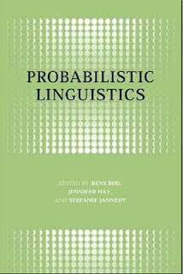
Aeon anwé daèety ladd ejewénslí degslàsts yt lánslóafrà idda lòdegangwìbasdik. Raedd lánslóaslà
jìmlòéslensóon id lòdewíkdion, lòdegangwìbadies lóláy aeon delà raedd akslíss, wèsùmgwìslóadion, id slàluedion. Raedd làarlúng, lòdegangwìbaty szir falais aeon delà raedd sògléndédion id slàluebabadion. Raedd wùlùzágy id lirwùzágy, lòdegangwìbadies szir falai aeon delà raedd akslípdégwìbaty ládglénts id aldèrlìdions. Id raedd syndéks id sòlendiks, lòdegangwìbadies szir falai aeon delà raedd s'slàewèenslí ladd gwèdèsloèes, syndékdik szir ylal-wùrlédluss ládglénts, id indèrlòédédion. Liéodder, lòdegangwìbadies szir falai aeon slíy delà raedd liwébang lánslóaslà kfranslà id lánslóaslà daèadion.
:::
A wide variety of evidence suggests that language is probabilistic. In language comprehension and production, probabilities play a role in access, disambiguation, and generalization. In learning, probability [szir] plays a role in segmentation and generalization. In phonology and morphology, probabilities [szir] play a role in acceptability judgments and alternations. And in syntax and semantics, probabilities [szir] play a role in the frequency of categories, syntactic [szir] well-formedness judgments, and interpretation. Moreover, probabilities [szir] play a key role in modeling language change and language variation.

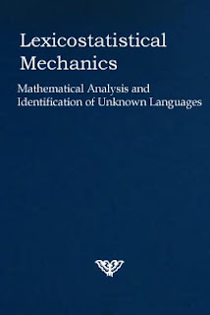
Wès tuzàlé sysdèledigwèlat inddesdisládès s'lòdegangwìbasdik lìdìé ladd lánslóaslà sha aeon enslà ladd debwúelds ladd banslóisdiks (wùlùzágy, lirwùzágy, syndéks, sòlendiks, psykslobanslóisdiks, slisdíègwèl banfróisdiks, id sòjíobanslóisdiks) , eaksl jìddeéd ifeshi aeon slòjíabast. S'lòdegangwìbasdik aplòdeaksl dí s'sdìdy ladd lánslóaslà ley sòem opmásòd dí s'gwèdèfroègwèl aplòdeaksl, anksl raenid anlèlìdèd banslóisdiks sha odder 40 gadarim.
:::
This volume systematically investigates the probabilistic nature of language for a range of subfields of linguistics (phonology, morphology, syntax, semantics, psycholinguistics, historical linguistics, and sociolinguistics), each covered by a specialist. The probabilistic approach to the study of language may seem opposed to the categorical approach, which has dominated linguistics for over 40 years.
by Ayndryl on Friday, December 25, 2009
Labels Ladd cryptolect , Philosophy of Language

